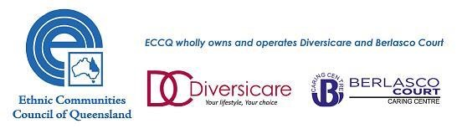

Home Care Worker – Casual

- Casual opportunity offering Salary Packaging
- Sunshine Coast Location (Nambour / Noosa)
- Deliver care to elderly clients

About ECCQ
Established in 1976, ECCQ has a long and proud history of leading and contributing to the development of Queensland as a successful multicultural society. ECCQ’s focus is supporting and advocating for the needs, interests and contributions of culturally and linguistically diverse communities in Queensland and providing culturally inclusive health services, information and education. We believe that everyone, irrespective of their background, should be able to participate in and contribute to all aspects of Australian life.

A division of ECCQ, Diversicare, has delivered culturally appropriate in-home care since 1989. Diversicare provides community and in-home care to older people and people with disabilities, as well as health education and resources to consumers and aged care providers.

About the role
We are seeking to recruit a passionate Home Care Worker committed to providing the best care possible to our clients in the Nambour / Noosa area. As a casual Home Care Worker, you will provide domestic cleaning, meal preparation, social support, shopping and personal care services, in home respite and sometimes centre- based respite to Diversicare clients.

Candidates who have worked in a similar role within the Aged Care industry will be highly regarded.

The ideal candidate will have:

- A passion for helping vulnerable people
- Proven previous experience in a similar role
- A Certificate III in Aged, Individual Support or Community Care
- Proven understanding of the Aged Care Standards
- A current satisfactory National Police check or be willing to undergo a police check
- A current Open Australian drivers license with nil restrictions
- A current First Aid certificate
- Access to a roadworthy registered vehicle that is comprehensively insured for work purposes

Applications
In order to be considered for this role, please complete your application including the following:

- Cover Letter – Clearly outlining how you meet the role requirements, including your cultural fit within ECCQ and with how you meet the key accountabilities listed in the role statement. No more than two pages in total.
- Current CV

Please email your application to jobs@diversicare.com.au. The closing date for this position is Friday 26th February 2021. For all other general enquiries please contact Anne Kropp, People Services Administrator on 3017 2740.

